Lab 2: Setting Up the Database Context for a Retail Store

Objective

To configure the Entity Framework Core DbContext, create entity models (Product and Category), and establish a connection to SQL Server.

Software Requirements
- Visual Studio Code
- .NET 8 SDK
- C# Dev Kit Extension
- SQL Server Express / SQL Server Developer Edition
- SQL Server Management Studio (SSMS)
- Windows 11

Commands Used

dotnet add package Microsoft.EntityFrameworkCore.SqlServer --version 8.0.8

dotnet add package Microsoft.EntityFrameworkCore.Design --version 8.0.8

dotnet build

Program.cs
Category.cs
using System.Collections.Generic;
namespace RetailInventory.Models
{
public class Category
{
public int Id { get; set; }
public string Name { get; set; }
public List<Product> Products { get; set; } = new List<Product>();
}}
Product.cs
namespace RetailInventory.Models
{ public class Product
{
public int Id { get; set; }
public string Name { get; set; }
public decimal Price { get; set; }
public int CategoryId { get; set; }
public Category Category { get; set; }
}
}
AppDbContext.cs
using Microsoft.EntityFrameworkCore;
using RetailInventory.Models;
namespace RetailInventory.Data
{
public class AppDbContext : DbContext
{ public DbSet<Product> Products { get; set; }
public DbSet<Category> Categories { get; set; }
protected override void OnConfiguring(DbContextOptionsBuilder optionsBuilder)
{ optionsBuilder.UseSqlServer(
"Server=localhost\\SQLEXPRESS;Database=RetailDB;Trusted_Connection=True;TrustServerCertificate=True;");
}
}
}

Program.cs

using RetailInventory.Data;

Console.WriteLine("Retail Inventory System");

Console.WriteLine("Lab 2 - Database Context");

using var context = new AppDbContext();

Console.WriteLine("DbContext Created Successfully");

Output

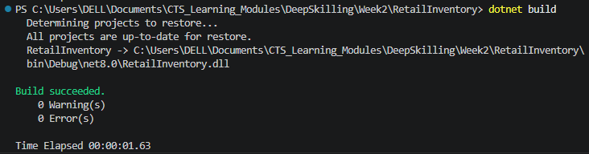

Result
The Product and Category entity classes were created successfully. The AppDbContext was configured successfully, and the project built successfully.

